ML CLASSIFIER PROJECT – DEVELOPER DOCUMENTATION
- Introduction
The ML Classifier Project is designed to automate the classification and analysis of user reviews. Its primary goal is to process raw textual, clean and normalize it, detect sentiment polarity (positive, negative, or neutral), and extraction suggestion-oriented statements.
This project serves as a foundation for automating customer feedback evaluation and understanding the behavioral trends based on textual statements.
This project is introduced for “Myworldlinkapp” to filter the reviews of app. How many positive, negative and neutral as well as reviews with suggestions are there? To make correct predictions and data analysis.
This project serves as a foundation for automating customer feedback and evaluation and understanding behavioral trends on textual sentiment.
The system is structured as a complete end-to-end NLP pipeline, beginning from data ingestion to result storage and visualization. It ensures data consistency, scalability, and maintainability for further machine learning experimentation.

- Tools and Technologies Used

Category | Tool/Library | Purpose/Description
Programming Language | Python 3.13 | Crore programming language used for the entire project
Data processing | Pandas, NumPy | Data manipulation and cleaning
Natural Language Processing (NLP) | nltk, emoji, re(regex) | Tokenization, stopword removal and emoji handling
Machine Learning | Hugging face transformers | Pre-trained transformer model for sentiment classification
Database | SOLite3 | Local database for persistent review and suggestion storage
Visualization/Dashboard | Streamlit (optional) | Interactive front-end for displaying results and analytics
Concurrency | ThreadPoolExecuter | Enhances performance by parallelizing review processing
Development Environment | Visual Studio Code | Main IDE used for writing, debugging, and testing
Version Control | Git & GitHub | Source code tracking and collaborative development

- System Architecture
The system follows a modular, layered and architecture separating preprocessing, analysis, and storage.
Each component communicates through CSV files or the SQLite database, ensuring data portability.
Architecture Diagram

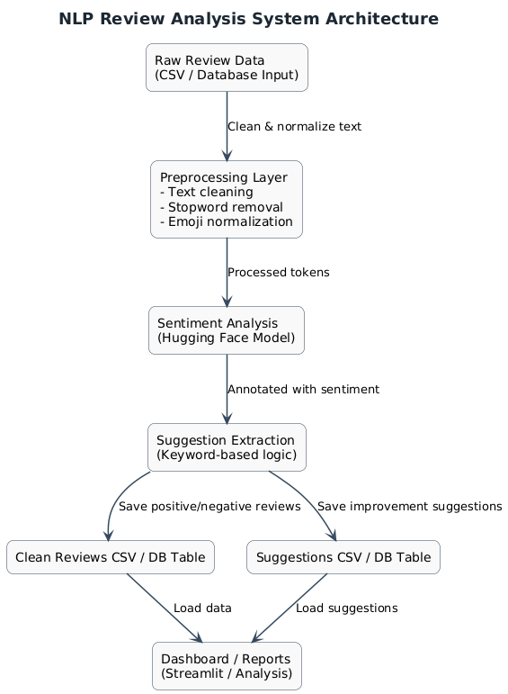
- Workflow Explanation
The project’s workflow is divided into five main phases, ensuring traceability and modularity.
Step 1: Data Ingestion
- Input data is fetched from data/raw_reviews.csv or the reviews.db SQLite database.
- Each review contains columns as id, rating, and content.
Step 2: Data preprocessing
- Conducted in preprocessing.py
- Includes:
- Lowercasing the text,
- Removing punctuation and emojis
- Tokenization
- Stopword filtering

- (The cleaned data is stored in data/cleaned_reviews.csv.)

Step 3: Sentiment Classification
- Performed in pipeline.py
- Uses DistilBERT model (distilbert-base-uncsed-finetuned-sst-2-english) for prediction.
- Outputs sentiment labels: positive, negative, or neutral.

Step 4: Suggestion Extraction
- Performed in pipeline.py
- Uses DistilBert model (distilbert-base-uncased-finetuned-sst-2-english) for prediction.
- Outputs sentiment labels: positive, negative, or neutral.
Step 5: Data Storage & Visualization
- Data/cleaned_reviews.csv
- Data/suggestions.csv
- Reviews.db

